**Introduction**

The Heart Disease mortality rate within the U.S is constantly increasing. According to the CDC in 2021 and 2020 Heart disease was the considered the #1 killer, it out beat cancer and covid-19. Not only is it number one it is still growing every year. Heart disease covered 20% of the United States Deaths for 2021. The CDC defined heart disease as major cardiovascular disease, heart disease, acute myocardial infarction, coronary heart disease, heart failure and strokes.

The data set we chose discusses heart disease mortality rate for people over the age of 35. The data set is set for the year of 2014 and discusses the mortality rate for each county in the United States per 100,000 people. This included age adjusted data and people who had 3 years average of dealing with heart disease. Each county also discussed the gender, race and longitude and latitude of each county. This study goes into the data set and tries learning the impact, gender, race, and the state you chose to live can impact you having heart disease. The model focuses specifically on the individual data provided instead of the overall gathered inside the dataset. The overall dataset is included in the research to see how close the overall data and individual data is related to each other. The goal is to raise awareness to how your gender, race and the state you live in can impact your life and chances to have heart disease and die from it.

**Data Cleaning/Preparation**

The dataset itself had 59077 unique rows and 19 columns within itself. We initially started the project by reading in the dataset. From there we noticed a lot of columns had blank/invalid data and had a column with the label that discusses which rows had insufficient data. Removed those columns. Next, we had to remove the rows that had the overall label within stratification 1 and 2 (this is for gender and race). We wanted to focus on the individual data itself for our test instead of focusing on the overall data for all races and genders for better inferential testing. Next, we focused only on keeping the county data specifically. We did not want the overall data for states or the nation as this was going to broad for the test. Finally, we renamed the columns to better readability and easier testing.

Another dataset we did clean up as well was for overall. We wanted to keep an overall dataset for exploratory data/visual analysis. This helps keep reference on what data looked like compared to when combined. This followed the same process as discussed before but reversed it to where we only kept overall for stratification 1 and 2.

Next, we had to identify outliers within each set. The outliers we focused on were within the column that discussed heart disease mortality rate. We removed the outliers by creating a function to get the interquartile range, quarter 1 and quarter 3 to get the lower/upper bound with the formulas:

lower_bound = Q1 - 1.5*IQR

upper_bound = Q3 + 1.5*IQR

This covers over 95% of the data and removed outliers that went well beyond the scope of the lower/upper bound. This function ran against both datasets we cleaned up. After all this was done, we had two clean datasets to analyze and interpret.

**Exploratory Data Analysis**

As we started to graph the data, first started to look at the five number summary for our cleaned-up data. We see from our cleaned data that the mean and is around 347 people out of 100,000 population and the overall data showing about 353 people. Looking at the standard error rate, it is .68 units (people), which is low. This means that our individual data is very similar to our overall data.

Next, we looked at the distribution for heart disease mortality rate. Below are the results.

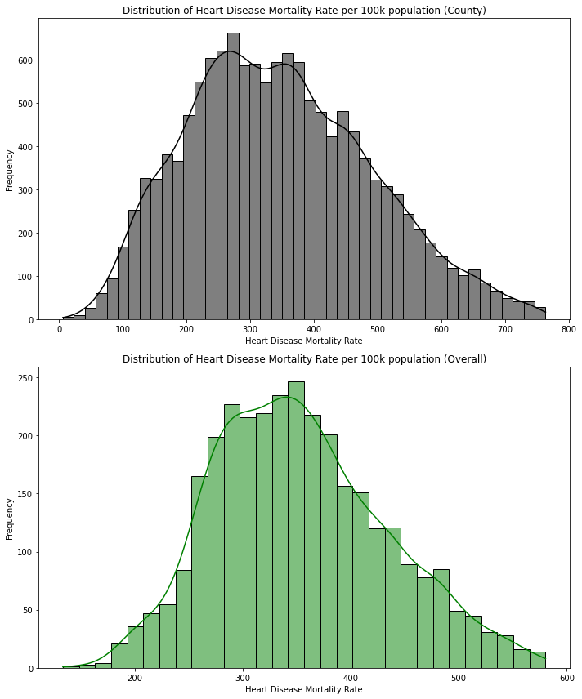

The two graphs highlight that both are of normal distribution. This mean that our data is following the central limit theorem can be used for our testing and modeling in determining the cause for high/low heart disease mortality rates for people over 35 years old.

Next we started to look at our independent variables and see how they are associated with the mortality rate in bar graphs

This graph above breaks out the count of amount of people for each race who were part of the statistic. As highlighted above, White has the most count for the mortality rate. The lowest is American Indian and Alaskan Native. This will allow us to use White as the default race for future testing.

The graph above highlights the count for males and females for the mortality rate. As you can see the count is very close to each other showing we have a good representation for each gender. A screenshot of a screen

Next, we looked at the count by the states. We included the overall to see if there was any associated difference from states. Looking at this, this shows there are some states not included in the individual data. This was due to insufficient data collected for the independent variables and the mortality rate. This does correlate well with general populations of each state. This is highlighted with Texas on the high side having bigger populations and same on the lower side with Hawaii not having a lot of counts.

Next we created boxplots to look at the independent data related to the mortality rate and to see if there are any outliers and generally how the distribution will look. This included the overall dataset as well as the overall for each independent variable. This is to see how the individual statistics compared to the combined stat.

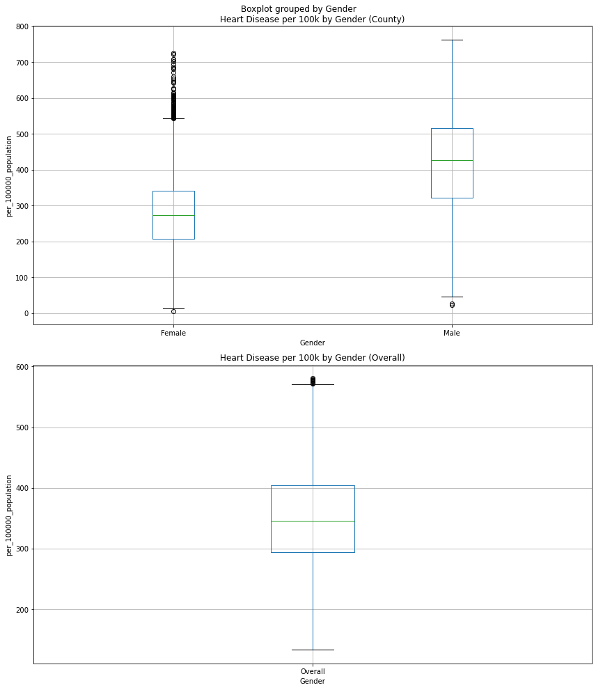

Looking at the bar graph, we can see that males have an overall higher amount of people affected than females. The females do have a considerable amount that are outliers. Comparing it to the overall statistic. We can see that the ceiling is considered lower compared to the individuals. The ceiling is only 600 instead of being around 750.

Looking at race, we can see Black has the highest average amount out of all the races. It is interesting to not that they do not have any outliers and neither do American Indian and Alaskan Natives. In fact, American Indians and Alaskan Natives show very similar results to Black which is considerable since they had the lowest count. Next, we see White falling in the middle. With minimal outliers. Hispanic is actually the race that has the most outliers including some counties reaching almost the ceiling. Finally looking at Asian and Pacific Islanders, we can see they have the lowest average. Interesting note is they do have one outlier that stands above the rest with one county having about an average of 720. Comparing this to overall, we see White having the closets average. The ceiling is lower as well for this with it being closer to 600 than 800.

After the visual analysis, we ran chi square test to test for association between the assumed independent variables and for creating hypotheses for our testing. We also ran z testing as well to see if there was any significant impact on the heart rate with the other categories.

Category Chi-square statistic p-value

0 Gender 7.171499e+03 3.097805e-69

1 Ethnicity 2.560000e+04 2.355235e-111

2 County 9.512658e+06 1.000000e+00

3 State 2.557907e+05 9.999865e-01

Looking at the Chi square testing suggest that gender and ethnicity have highly significant association with the mortality rate. The large statistic and miniscule p value show the strong relationship. Looking at state and county, there is not statistical association. County has a perfect 1.00 for the p-value which indicates no association. With state having a value extremely close to 1.00 it falls similar to county.

For z testing for gender we saw that females have a p-value of less that .05 with a z-statistic of -56 which shows that there is a significant impact with being a female and that the mortality rate is lower. For male even with having 39 this p-value was 2.0 which indicates there was no association. Since females did show significant impacts, this suggest that there is a noticeable difference which will lead to some hypothesis testing once we start looking at modeling and model analysis.

Looking at the z testing for race, there was significance for Hispanic and Asian and Pacific Islander. For Hispanic the z-statistic was -58 and Asian and Pacific Islander -81. Both show that the significant impact will affect the average to be lower. This indicates that that some hypothesis testing can happen on this variable when we start looking at models.

There was z testing for state as well. To see if there were any significant impacts on the mortality rate. It is worth noting that with such a small p-value with chi square test the results could be due to random chance and not due to statistical significance. From the z test it showed that Arizona, California, Colorado, Connecticut, Delaware, Florida, Iowa, Idaho, Louisiana, Massachusetts, Maryland, Maine, Minnesota, North Carolina, North Dakota, Nebraska, New Hampshire, New Jersey, New Mexico, Nevada, New York, Oregon, Pennsylvania, Rhode Island, Utah, Virginia, Vermont, Washington, and Wisconsin show statistical significance.

In terms of going to the next phase of modeling on this data, the best variable to use will be gender and race since the chi square test showed association and there were variables in each category that showed significant impact. There can be testing on state category as well but this will be less significant due to the chi square p-value. It will still be good to see how the states listed above are modeled.

**Model Selection**

Looking into models that we can use for gender and race there are some factors to consider. Heart Disease is continuous float data, ethnicity and gender are categorical data. State is categorical data too. This is less important since ethnicity and gender are the main categories we will be testing. Knowing this some models we considered was linear regression/multilinear regression, logistic regression, clustering, and naïve bayes.

Since Naïve bayes focuses mostly on categorical data and our target data is continuous this removed it from consideration. For logistic regression, this focuses more on classification outcomes which is opposite of what we are trying to solve with our continuous data.

Next with multi/linear regression which helps focus on our target variable and helps predict what the mortality rate could be depending on gender and ethnicity. This will also allow us to see the impact of both independent variables together on the target variable. Finally with cluster, we kept this model to potentially look at more exploring patterns and see similar grouped observations. This is to see if there are any patterns that are driving the mortality rate up that is not known.

**Model Analysis**

Knowing that our models are multi/linear regression and clustering we started formatting our dataset to fit the models. All categorical variables had to be hot encoded to be able to be used. After that hypotheses were created that worked with the significant data found before and the models that were decided.

Hypothesis 1: There is a significant difference in heart disease mortality rates between genders.

Null Hypothesis (H0): There is no significant difference in heart disease mortality rates between genders.

Alternative Hypothesis (H1): There is a significant difference in heart disease mortality rates between genders.

*All genders are tested but females were the primary subject to see their significant impact

The model used was linear regression for this hypothesis. Looking at the results, this model covers 23.6% of the variation to predict the dependent mortality rate. This is considered low and only explains a small portion of the mortality rate. The model showed that female (const) had a default of 276 people in a 100,000 population for the mortality rate. Males had a significantly higher amount of people with an increase of 140 people. The p-values for this model showed this each gender was significant. The condition number shows there was no multicollinearity. The results show to reject the null hypotheses and accept the alternate.

Females is the lower sloped line.

Hypothesis 2: There is a significant difference in heart disease mortality rates between ethnicities.

Null Hypothesis (H0): There is no significant difference in heart disease mortality rates between ethnicities.

Alternative Hypothesis (H1): There is a significant difference in heart disease mortality rates between ethnicities.

*All ethnicities are tested but the main subjects were Hispanic and Asian and Pacific Islanders

The model used was linear regression for this hypothesis. Looking at the initial results, there was an indication that multicollinearity was appearing. This was shown with the condition number being 1.44e+15. The test was redone by removing multicollinearity. There were a couple of ways to remove this. First the const was considered to be white. This helped with the hot encoding that happened at the start. If the new column White was dropped and all the other ethnicities columns are 0 then it is assumed the ethnicity was white. Next, we calculated the variance inflation factor (VIF). This helped to detect more multicollinearity among ethnicities. Any VIF values that were to high (greater than 10) were removed due to them being able to cause unstable and unreliable estimates. This model covers 34% of the variation to predict the dependent mortality rate. This is considered moderate and only explains a moderate portion of the mortality rate. This shows the variable is a good fit but can be improved with additional exploration. The model showed that white (const) had a default of 368 people in a 100,000 population for the mortality rate. Black had a higher amount of people with an increase of 60 people, and American Indian and Alaskan Native had an increase with 35. Looking at the variables that were considered to have a significant impact, Hispanic decreased by 151 and Asian and Pacific Islander decreased by 195. Both of these ethnicities cut the const by about half by having them included. This shows their ethnicities mortality rate is significantly lower than the other three. The p-values for this model showed this each ethnicity was significant. The condition number shows there was no multicollinearity, and this issue was fixed. The results show to reject the null hypotheses and accept the alternate. This also shows the big impacts are Hispanic and Asian and Pacific Islander proving and following in line with the z test.

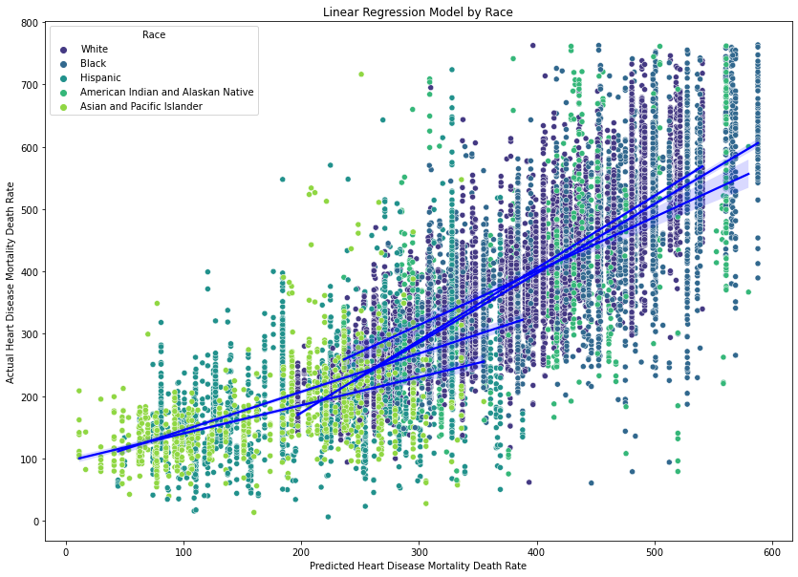

The two lower sloped lines are Hispanic and Asian and Pacific Islander. The graph shows how they are significantly different from the other ethnicities.

Hypothesis 3: There is a significant interaction effect between gender and ethnicity on heart disease mortality rates.

Null Hypothesis (H0): There is no significant interaction effect between gender and ethnicity on heart disease mortality rates.

Alternative Hypothesis (H1): There is a significant interaction effect between gender and ethnicity on heart disease mortality rates.

The model used was multilinear regression for this hypothesis. Looking at the results, this model covers 58.6% of the variation to predict the dependent mortality rate. Multicollinearity was addressed with the method used previously for ethnicity. This is considered moderate and explains a moderate portion of the mortality rate. The model showed that white female (const) had a default of 297 people in a 100,000 population for the mortality rate. Males had a significantly higher amount of people with an increase of 140 people as well as a black male had the higher taking in both factors. For the lowest, an Asian or pacific islander female would have the lowest rate. Hispanic also showed significant impact by still having negative 155 for the coefficient. The p-values for this model showed each variable was significant. The condition number shows there was no multicollinearity. From the two previous graphs shown shows the variables that are showing a significant impact are trending to have a lower mortality rate. The results show to reject the null hypotheses and accept the alternate.

Hypothesis 4: There is a significant difference in heart disease mortality rates between states.

Null Hypothesis (H0): There is no significant difference in heart disease mortality rates between states.

Alternative Hypothesis (H1): There is a significant difference in heart disease mortality rates between states.

*All states are test but the subjects were Arizona, California, Colorado, Connecticut, Delaware, Florida, Iowa, Idaho, Louisiana, Massachusetts, Maryland, Maine, Minnesota, North Carolina, North Dakota, Nebraska, New Hampshire, New Jersey, New Mexico, Nevada, New York, Oregon, Pennsylvania, Rhode Island, Utah, Virginia, Vermont, Washington, and Wisconsin primary subjects for significant impact.

The model used was linear regression for this hypothesis. This hypothesis focused mostly on the states we saw that did have a statistical significance from the z test with the understanding the association is close to no association. Multicollinearity was attempted to be addressed with the method used previously instilled into this category, which the VIF did remove Georgia and Texas, but there is still some showing with a condition number being 41.6. The threshold for this is 30 which it clearly passed. This is significant and taken into consideration for this test and knowing the result could not be valid and can be unreliable. Looking at the results, this model covers 16.6% of the variation to predict the dependent mortality rate. This is considered low and only explains a small portion of the mortality rate. The model shows the states that were shown to have a significant impact from the z test did have significant finding from there p-value. With knowing the chi square test results more testing would need to be done to make a decision on this hypothesis. There is too much variability happening for this to be decided.

In terms of clustering there were some noticeable patterns that could be associated. There were tied similar to our findings above

Asians showed they had the lowest ceiling this was show with the boxplot and now the cluster chart. This also showed there are a majority closer to their floor and ceiling. This still falls in line with the other ethnicities.

Hawaii data is very sparse and spread out. The cluster is not really happening and there is a wide gap between floor and ceiling.

**Conclusion and Recommendations**

Overall there is significant impact happening within gender and ethnicity. Both categories are contributing to showing patterns to have lower mortality rate. Females, Asian and Pacific Islanders and Hispanic are the main subjects showing these results. On the opposite side Black Males had the highest mortality rate. It is recommended to look more into the variable that have significant impact to be able and try to fully understand why they have a lower rate. Some assumption that could start a new study would be culture and diet for these ethnicities. For Females it could be looking at their diet compared to males as well as different living/societal standard that can contribute.

In terms of Hypothesis 4, for trying to find significance impacts from states, more testing would have to be done the Chi Square test itself showed there was no association, but the linear regression test did show there were some states impacting the study. Granted the impact was minor since only 16.6% was represented from the model. To further this study, I would try to tie the different ethnicities that were tested here around the world and focus more on the environment of the location and that could possibly tie into heart disease mortality rate for individuals over 35. Could being in a colder climate contribute or vice versa? Could a more humid climate lower the mortality rate? These are some questions that could tried to be answer as we dig closer to what fully contribute to middle age heart disease death.

Citations

(overall example)

<https://ieeexplore-ieee-org.sandiego.idm.oclc.org/document/10040352?arnumber=10040352>

^ Example I recommend we try to follow for formatting and all that

Links for introduction section

<https://www.cdc.gov/nchs/nvss/deaths.htm>

<https://www.cdc.gov/nchs/data/databriefs/db456-tables.pdf#4>

<https://www.cdc.gov/dhdsp/maps/dtm/data_sources.htm>